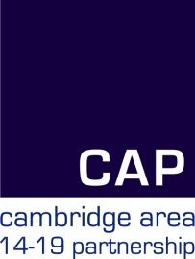
CAP Transition Workshop

Thursday 13 September 2018
9.00am – 3.15pm
Swavesey Village College, CB24 4RS

Programme

09.00 – 09.15 | Prospectus distribution in the car park
09.15 – 09.30 | Registration and coffee
09.30 – 9.40 | Welcome and introductions - Sarah Pattison Chair of Transition Group
9.40 – 10.00 | Careers Strategies – Laurie Simpson, Bottisham VC
10.00 – 10.15 | The Quality Award – Janet Harris, CCC
10.15 – 10.30 | Refreshments
10.30 – 11.00 | The Apprenticeship Route – Anne Bailey, Form the Future
11.00 – 11.30 | Vocational Options – Marcus Doyle (CRC) / Steve Dann (Long Rd)
11.30 – 12.30 | ‘Speed networking’ Part 1 with the Post 16 centre  Updates on Programmes of study, curriculum changes, new initiatives and key messages
12.30 – 13.15 | Buffet Lunch
13.15 – 14.15 | ‘Speed networking’ Part 1 with the Post 16 centres  Updates on Programmes of study, curriculum changes, new initiatives and key messages
14.15 – 14.45 | Move on Up: considering University – Hannah Owens, UEA
14.45 – 15.15 | Updates for those new to careers  This session is just for those new to the process; please book before the day

To book this event please visit the CAP website
https://www.cap14-19.org.uk/page/?title=CAP+Transition+Workshop+2018&pid=179

There is no charge to schools and colleges who are members of CAP or those working for Cambridgeshire County Council and supporting young people. There is a £55 per person charge for state schools and colleges who are not members of CAP, and a charge of £105 per person for those from the private sector. All attending are asked to book a place.

